**Predictive Analytics for Content Development - Entertainment Sector**

Pooja Joshi & E.Code [E25007]

# Overview :

# The "Predictive Analytics for Content Development" project aims to utilize historical data and analytical models to predict trends and performance of content in the entertainment industry. By analyzing data such as popularity, sentiment, audience engagement, and content ratings, the goal is to develop models that can guide decision-making processes for content development, marketing, and overall strategy in the entertainment sector.

# Objective:

The primary objective of this task is to explore predictive analytics techniques for forecasting the performance of entertainment content. The focus is on understanding how sentiment, audience preferences, and content features impact content success.

# Assigned Task(s) :

· **Task 1**: Implement predictive models using historical data to forecast content performance.

· **Task 2**: Evaluate different machine learning algorithms for accuracy in predicting success factors.

· **Task 3**: Create visualizations to present the results of predictive analysis effectively.

# Task Details :

**Task 1:** Develop and evaluate predictive models for content performance using historical data.

Status: In Progress

Details: The initial phase of the task involves data preprocessing, including cleaning the dataset and addressing any missing or inconsistent values. Afterward, various predictive models (e.g., linear regression, decision trees) are being trained and tested on the dataset.

**Task 2:** Assess the accuracy of different machine learning algorithms for predicting content success.

Status: Not Started

Details: This task will involve testing algorithms such as Random Forest and Support Vector Machines (SVM) on the data to determine the most effective models for prediction.

**Task 3:** Create visualizations for presenting predictive analysis results.

Status: Completed

Details: Visualizations, including bar charts and scatter plots, were created to show correlations between different content features and their success metrics. These charts will be included in the final report.

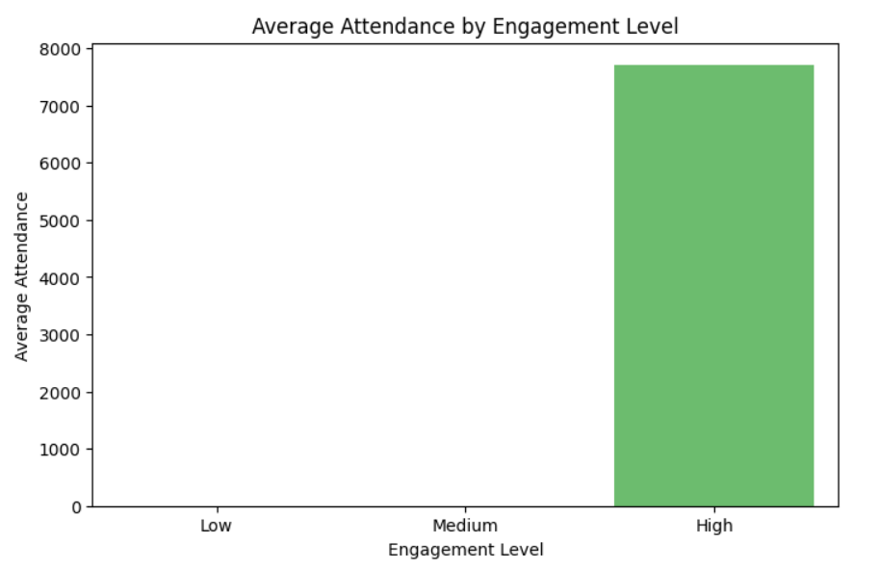

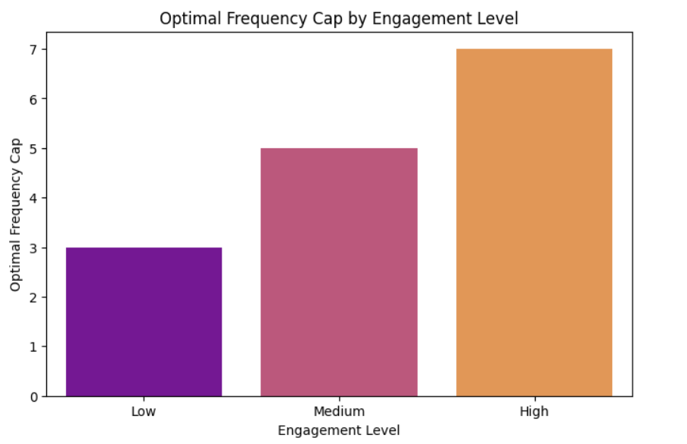

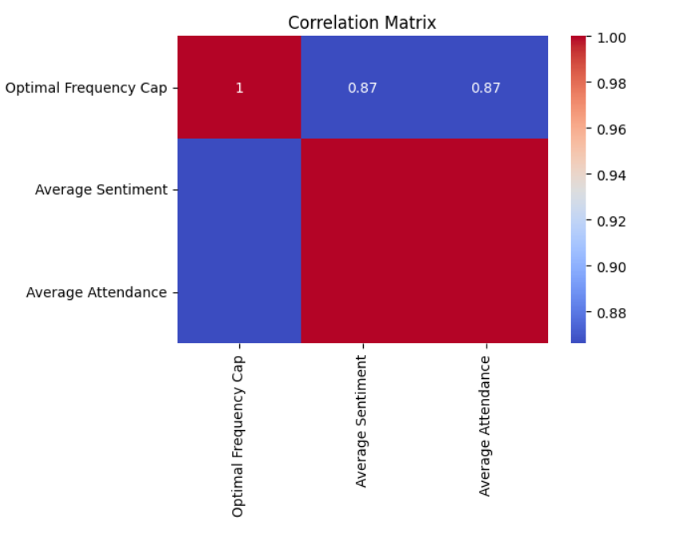

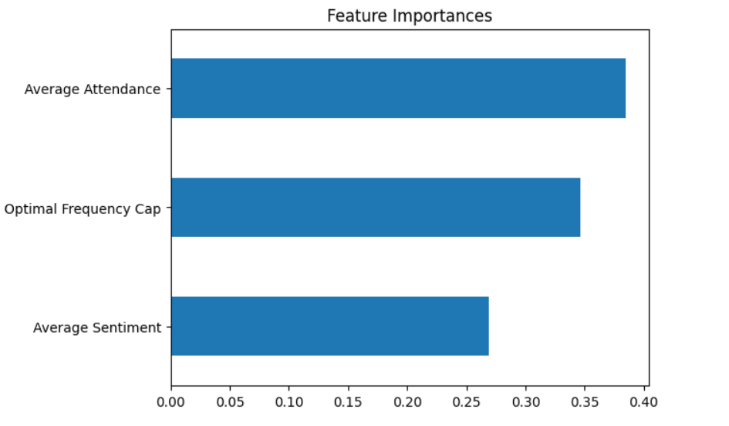

**Progress :**

· **Accomplishments**:

* Preprocessed the dataset for use in predictive modeling.
* Completed initial model training with linear regression, providing baseline performance predictions.
* Generated visualizations to explore key features affecting content performance.

· **Metrics**:

* Model Accuracy: The initial linear regression model showed an R-squared value of 0.72.
* Sentiment Analysis: Positive correlation of 0.63 with content performance ratings.
* Visualization: A bar chart showing the impact of content sentiment on user ratings was completed.

# Challenges and Solutions :

· **Challenges Faced**:

* The dataset had missing values and inconsistencies that delayed the preprocessing phase.
* Some machine learning models required significant computational resources for training, slowing down the testing phase.  
  [Times New Roman - 12]

· **Solutions Implemented**:

* Missing data was handled using imputation methods, replacing missing values with the median for numerical columns and the most frequent value for categorical data.
* For resource-intensive models, cloud computing resources were utilized to speed up the testing process.

**Next Steps :**

· **Upcoming Tasks**:

* Complete the evaluation of different machine learning algorithms (SVM, Random Forest).
* Refine the models based on the evaluation results and adjust hyperparameters for improved performance.  
  [Times New Roman - 12]

· **Goals**:

* Finalize the predictive models and present them with high accuracy for forecasting content success.
* Ensure all results are backed by robust visualizations and clear explanations.

# Conclusion :

### Summary:

# In summary, progress has been made in preprocessing the data and testing initial models for predicting content performance. Challenges related to data quality and computational resources have been addressed, and visualizations are in place to support the findings. The next steps involve evaluating additional models and refining predictions.

# **Acknowledgments**: Thank the audience for their time and attention.